Project Name | Queen Mary Infant and Nursery School
Date | 02/03/2026
Document Version | 1
Author | Mel Castle


Business Case
Background and Scope (What are you hoping to achieve by the proposed changes?)

Context
Queen Mary Infant and Nursery School is maintained by North East Lincolnshire Council (NELC). There are currently 278 children on roll from nursery to year two (206 in the main school with a capacity of 270). The main school’s published admissions number (PAN) is 90. The nursery PAN is 65 FTE (130 part time places) places. There are currently 72 children on roll in the nursery.

Reasons for change
In recent years we have experienced reducing pupil numbers – see data below
Pupil numbers –
Summer 2022 – 327 pupils – 90 in nursery and 237 in main school
Summer 2023 - 328 pupils – 104 in nursery and 224 in main school
Summer 2024 – 313 pupils – 81 in nursery and 232 in main school
Summer 2025 – 305 pupils – 92 in nursery and 213 in main school
Summer 2026 – 278 pupils – 72 in nursery and 206 in main school

Projections for Autumn 2027 are currently 227 pupils – 28 in nursery and 199 in main school (based on current applications)

In addition to falling pupil numbers, we have seen a rapid increase in the number of pupils with EHCPs (Education Health and Care Plans) or accessing EYIF (Early Years Inclusion Funding). Although this generates some funding for the school, the cost of staffing to support these pupils far outweighs the funding received.
Number of pupils with EHCPs or EYIF –
Summer 2021 – 7 pupils with EHCPs and 6 accessing EYIF
Summer 2022 - 11 pupils with EHCPs and 6 accessing EYIF
Summer 2023 - 17 pupils with EHCPS and 10 accessing EYIF
Summer 2024 – 20 pupils with EHCPs and 11 accessing EYIF
Summer 2025 – 30 pupils with EHCPs and 14 accessing EYIF
Sumer 2026 – 21 pupils with EHCPs and 5 pupils accessing EYIF

Projections for Autumn 2026 – 17 pupils with an EHCP and 5 pupils with an EHCaR underway/submitted.

Currently these pupils are supported across a number of mainstream classes and they require high levels of additional staff support to manage their needs and ensure they are safe.

Summary
The school will be overstaffed for September 2026 due to falling pupil numbers and if the school retains its current levels of staffing, the staff salary costs will exceed the school’s income The summary below is based on current staffing levels and shows that retaining these staffing levels causes the accumulated surplus position to turn to a deficit position in 2026/27 and beyond.

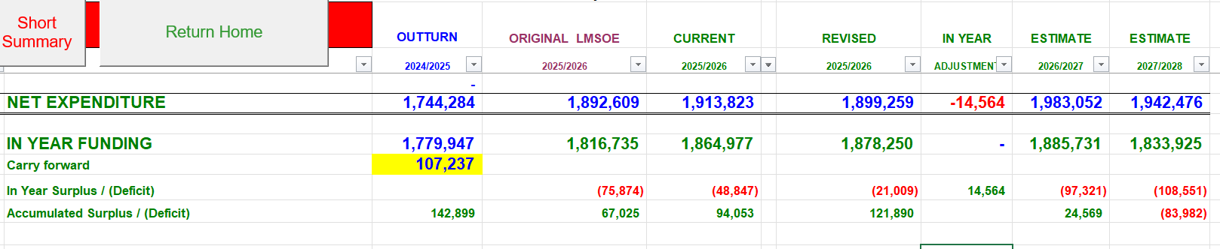
In order to combat this, we propose a change to class organisation as illustrated below
 | Current | Proposal
Nursery | 3 teaching groups | 2 teaching groups
FS2 | 3 classes | 2 classes
Year One | 3 classes | 3 classes
Year Two | 3 classes | 2 classes
Inclusion classes | 0 classes | 2 mixed age classes

Through the creation of two inclusion classes, we will be able to -
- provide a more suitable environment which better meets the needs of some pupils with communication and interaction needs
- allow them to access highly structured, communication-rich teaching approaches
- ensure pupils with complex communication and interaction needs receive quality-first teaching matched to their developmental stage, not chronological age.
- create supportive and predictable bases from which pupils can access mainstream activities in a planned, successful way (e.g., assemblies, playtimes, targeted lessons).
- reduce behaviour incidents and distress, enabling pupils to engage more positively in school life
- concentrate expertise and resources (e.g., sensory equipment, communication aids, therapy input) in one area
- reduce staffing levels through more strategic deployment of Teaching Assistants and specialist staff

Other Considerations – have other options been considered. Which other services need to be aware – consider reputation, financial, legal implications
Before progressing to a proposal involving staffing reductions, the school undertook a thorough review of all feasible options to identify measures that could further reduce expenditure, increase income, or reorganise provision in a way that would preserve high-quality education, safeguard statutory duties, and maintain safe staffing levels. The following options were considered in detail.
Reducing Non-Staff Expenditure
The school systematically reviews non-staffing budgets. Actions include:
- Renegotiating or re-tendering service level agreements (cleaning, catering, ICT support) to secure efficiencies.
- Reducing non-essential expenditure such as subscriptions and discretionary curriculum spend.
Outcome:
Savings have been insufficient to meet the scale of the financial shortfall and could not sustainably address the ongoing budget pressure.

Reprofiling or Utilising Reserves
The school have reviewed available reserves and considered the extent to which they could be used to delay or offset staffing costs.
Outcome:
Reserves are required to maintain an appropriate level of financial resilience and using them to cover recurring staffing costs does not address the long-term deficit.

Increasing Income
The potential for generating additional income has been examined, including:
- Additional lettings of school premises.
- Expanding wraparound care or nursery provision where demand exists.
- Targeting grant opportunities or partnerships with community organisations.
Outcome:
Income generation has been insufficient to bridge the required savings and do not provide certainty or stability for future years.

Recruitment Controls and Vacancy Management
The school have implemented and reviewed the impact of:
- A general recruitment freeze for non-essential posts.
- Not renewing temporary or fixed-term contracts where lawful and appropriate.
- Reducing the use of supply cover except where required for safeguarding or operational reasons.
Outcome:
These measures do not deliver the level of recurring savings required to balance the budget.

Reviewing Leadership, Teaching and Administrative Structures
Consideration was given to:
- Combining leadership responsibilities.
- Streamlining administrative roles.
- Reductions to teaching staff deployment.
Outcome:
The current structure is required to ensure statutory compliance, safeguarding oversight, and effective running of the school. The school also reviewed the feasibility of reducing teaching roles; however, teaching capacity is already matched closely to statutory pupil–teacher ratios, the needs of pupils in EYFS and KS1, and the delivery of a broad and balanced curriculum. Any further reduction in teaching posts would compromise curriculum coverage, increase class sizes beyond acceptable limits, and significantly weaken the quality of education and targeted support for early learners. Further reductions in these areas would adversely affect operational capacity.

Operational Efficiencies
The school have examined options for savings through:
- Streamlining lunchtime supervision and wraparound provision staffing.
- Reviewing cleaning hours and administrative processes for potential savings.
Outcome:
The current operational structure is required to ensure statutory compliance, safeguarding oversight, and effective running of the school. The needs and age of pupils in our infant and nursery school mean that high levels of supervision, care and hands-on support are essential, and any further reductions would compromise safety, wellbeing and the quality of lunchtime and wraparound provision.

Conclusion
Through changes made in 2026-26, we have been able to reduce the planned in year deficit from £76, 874 to £21, 009 – see budget summary above. This week (wc May 4th 2026) we have been notified of a reduction in LGPS pension contributions for the next three years. In consequence, we have been able to further reduce the predicted deficit but not to a sustainable level.
After fully exploring all reasonable alternatives, the school conclude that the remaining financial deficit cannot not be addressed without changes to staffing. Staffing reductions therefore remain the only viable option to achieve a sustainable and balanced budget while safeguarding the quality of education and meeting statutory obligations.
Proposed Changes – outline here the planned changes to the service. This should include a before and after structure chart. Consider including an establishment report as an appendix.
Leadership:
No proposed changes
Teaching Staff
There will be a reduction of teaching staff from 12.2 to 11.6 FTE as two teachers have requested a reduction in hours. There are no further proposed changes.
Support Staff:
Reduce the support staff from 22.38 FTE to 17.25 FTE

This will include:
- Deletion of 2 Early Years Practitioner posts from the structure (currently 3 EYP roles)
- Deletion of 1 Level 3 TA post from the structure (currently 3 Level 3 TA posts)
- Deletion of 4 Level 2 TA posts from the structure (currently 22 Level 2 TA posts)

The structure refers to FTE posts. These posts are currently occupied by 31 staff members who face potential redundancy.
Admin staff:
There will be a reduction of admin staff from 3.01 to 2.88 FTE as one member of staff has requested a reduction in hours. There are no further proposed changes.
Premises, wraparound and lunch staff
No proposed changes to premises, lunch staff and breakfast-club staff.
After school care staff are currently working on a casual basis as staffing levels have been subsidised by DFE funding until April 2026. Funding will not continue after this date and we plan to evaluate the viability of continuing after school care in 2026-27 during the Summer term. This may create an additional post within school as 4 casual members of staff currently in post will soon qualify as TAs and are currently looking for full time positions in other schools.
Current structure
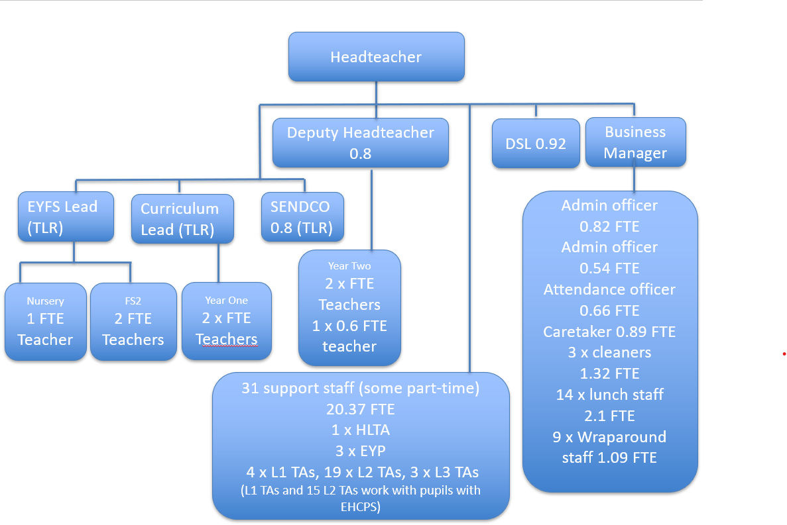
Proposed Staffing Structure
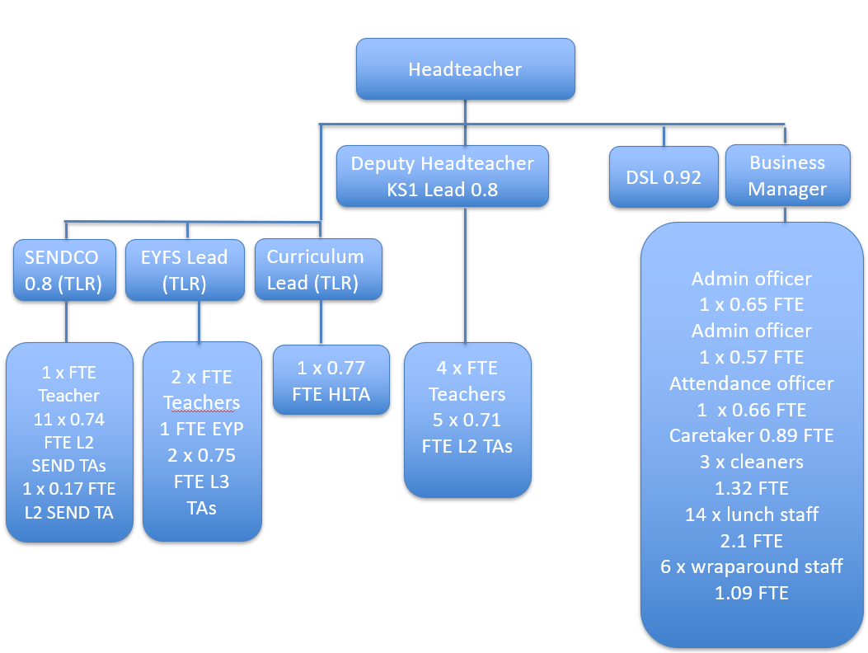
The impact of the proposed staffing changes on the budget are outlined below –
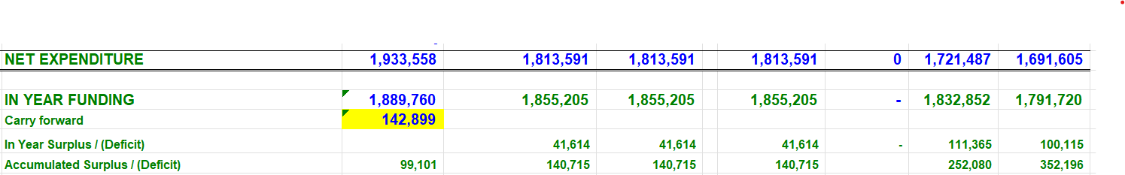
Potential Impact – outline here the impact of the proposed changes, such as number of posts/people affected, redundancies, role changes, other T+Cs, interdependencies with other services.
Leadership Roles
All leadership roles are unaffected as the school requires stable leadership capacity to maintain strategic oversight and ensure continuity of provision.
Teaching Roles
Aside from requested reductions in teaching hours, all teaching roles are retained, as the proposed class configuration maintains the current requirement for the same number of teachers.
HLTA
The HLTA post remains essential and is therefore not proposed for change, as senior and middle leaders will continue to require consistent and reliable cover to undertake their statutory and strategic leadership responsibilities.
Support Staff (teaching assistants and early years practitioners)
Reduction in support staff from 22.38 FTE to 17.25 FTE
There are currently 31 support staff occupying 22.38 FTE posts. We propose a reduction of 7 posts in this group; as some posts are shared by part-time staff there is the potential for up to 11 redundancies.
Premises, Wraparound Care and Lunch Staff
Premises, breakfast club and lunchtime roles are unaffected, as these functions are essential for maintaining site safety, daily operations and the required levels of pupil supervision.
After school care staff are currently working on a casual basis as staffing levels have been subsidised by DFE funding until April 2026. Funding has not continued after this date and we plan to evaluate the viability of continuing after school care in 2026-27 during the Summer term. This may create an additional post within school as 4 casual members of staff currently in post will soon qualify as TAs and are currently looking for full time positions in other schools.
Overall Impact
Reduction of 7 posts (as outlined above), which could equate to a maximum of 11 redundancies in the event that the affected positions are occupied by part-time staff, pending consultation and final structural decisions.
In the redundancy pool there are currently 2 staff who are over 55 and in the local government pension scheme which creates a risk around pension strain costs which can be significant. Dependent on timescales this rises to 3 in September and 4 in December.
Costs – outline here the potential costs of the changes identified – to include salary and oncosts, potential redundancy, pension costs and other T&C costs. How are the changes being funded?
Redundancy costs will be funded by the school’s delegated budget. The in year and accumulated surplus created by the proposed changes will cover these costs.
Please see the attached spreadsheets outlining the current and proposed staffing structures along with a costings report produced by Alex Allenby (Accountant, Accountancy, Business Partnering, North East Lincolnshire Council).

Timeframes – outline here the timeframes that the change is to be delivered by.
W/C 4th May - Business case to be considered by NELC senior leadership
Approximate timelines if business case is approved:
W/C 11th May 2026 – Notify unions of consultation
W/C 11th May 2026 - Staff engagement sessions.
W/C 18th May 2026 – First round of individual consultations
W/C 1st June 2026 – Second round of individual consultations
W/C 8th June 2026 - Conclusion of change management consultation. Redundancy or redeployment notices issued. Notice periods commence.
1st September 2026 – new staffing structure in place.

