Calculation Policy: A Parent’s Guide
Our school is committed to teaching mathematics across all age ranges in a lively and engaging way. A key part of your child’s learning in mathematics revolves around numbers and calculations, including addition, subtraction, multiplication and division.
This is a guide to help you understand the methods and strategies that we are teaching your children, hopefully this will help you to support your children with homework and their learning.
This guide is divided into 5 sections. These will show you the four number operations and the stages in which they are taught, plus a resource sheet.

1. Stages in addition methods
2. Stages in subtraction methods
3. Stages in multiplication methods
4. Stages in division methods
5. Resource sheet
Glossary:
Here is a list of key mathematical words or terms which we use within school when teaching the children maths.
- Multiple – the result of multiplying (x) a number by another number. Eg. 12 is a multiple of 3 as 3 x 4 = 12.
- Arrays – objects or numbers arranged in rows and columns.
- Repeated addition – adding the same number again and again.
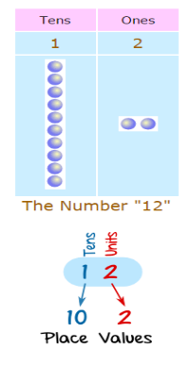
- Tens and ones – How many tens and how many ones (units) are in a number. (see diagram)

- Stages in addition methods
- Handling objects to add 2 amounts together.

+ =
- Using number lines to add one digit numbers. (If a number line isn’t available children are taught to draw their own.)
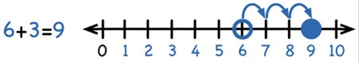

- Using a number line or hundred square to add tens. (If a number line isn’t available children are taught to draw their own.)
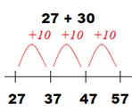

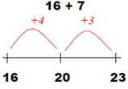
- Using a number line or hundred square to add one digit numbers bridging ten.

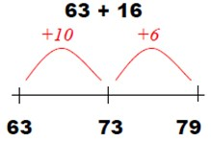
- Adding two 2 digit numbers by adding tens and then the ones. (split 16 into 10 and 6 )

- Partitioned column method (23 + 34 split to 20 + 30 and 3 + 4)
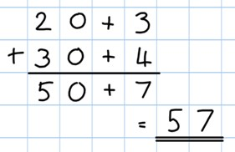

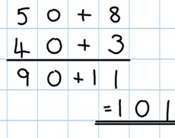
- Once children can add a multiple of ten to a 2 digit number mentally (e.g. 80+11) they are ready for adding pairs of 2 digit numbers that bridge ten (e.g. 58 + 43)
2. Stages in subtraction methods
- Handling objects to subtract an amount.
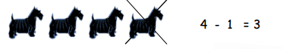
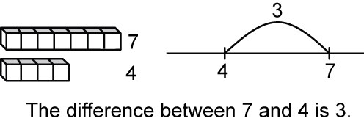
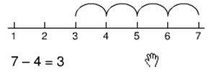
- Using number lines to subtract one digit numbers. (If a number line isn’t available children are taught to draw their own.)

- Using a number line to count back in tens and ones.
(start jumping back from the right hand side)
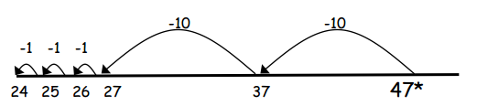
(Jump back in tens and then ones)

- Moving to more efficient ways of subtracting 2 digit numbers. (47 – 23 =)
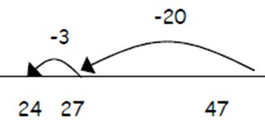

- Finding the difference between two numbers by counting up.
e.g. What is the difference between 82 and 47?
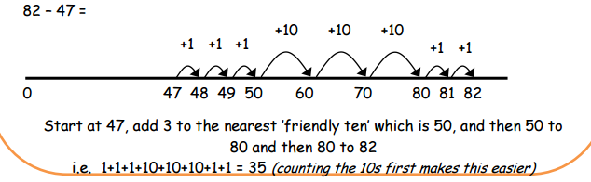

3. Stages in multiplication methods
- Multiplying with objects and drawing pictures.
3 x 2 = 5 x 3 =
3 groups of 2 5 groups of 3
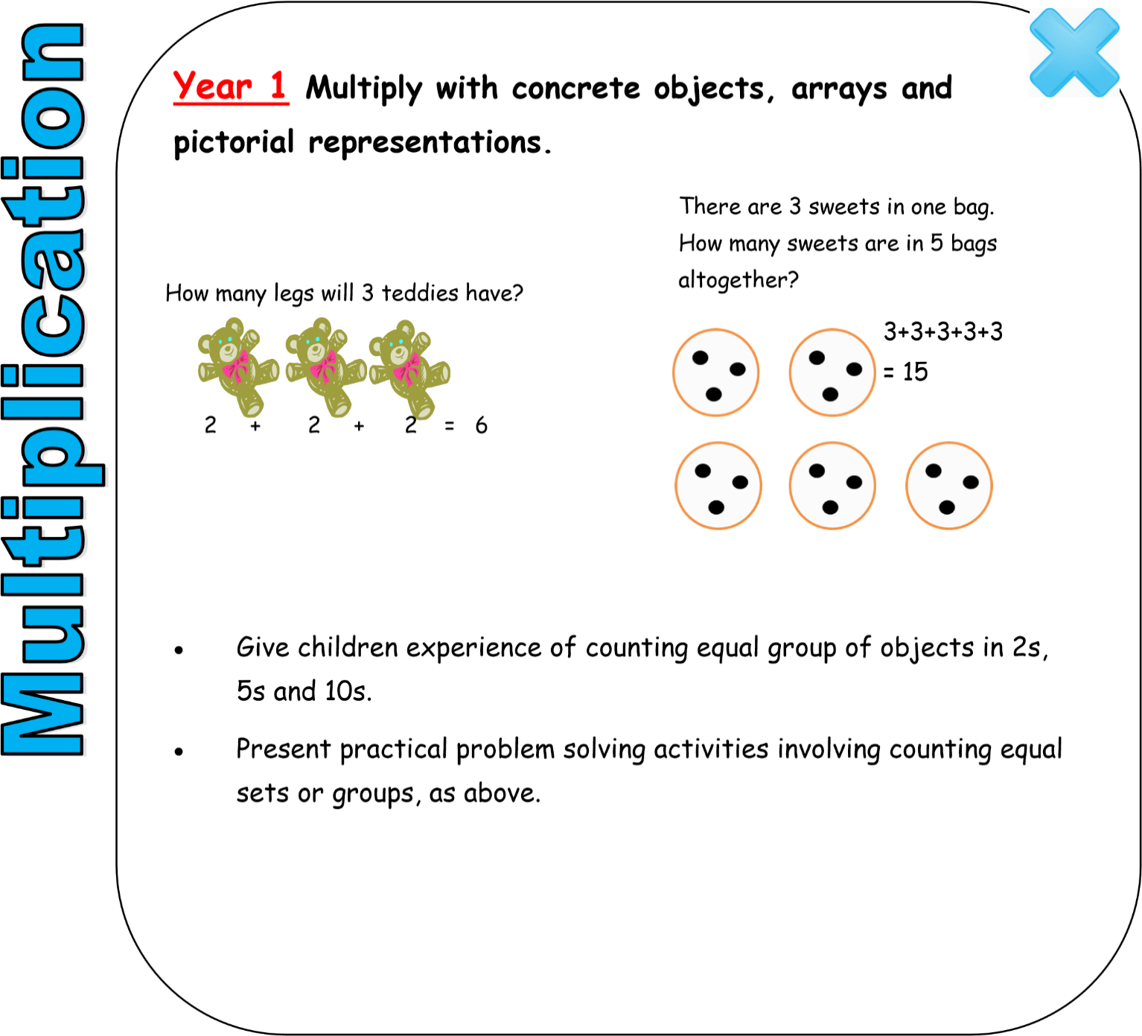

- Using repeated addition on a number line:
Starting from zero, make equal jumps to work out multiplication sums using x and =
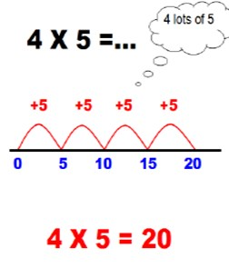

- Using arrays (without a number line):
Recognising that repeated addition is the same as multiplication. Using repeated addition in pictures or writing number sentences to solve multiplication problems.
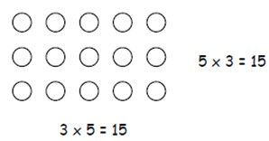
5 x 3 – 3 + 3 + 3 + 3 + 3 = 15
3 x 5 = 5 + 5 + 5 = 15

4. Stages in division methods
- Using objects and pictures to divide. (share and group)

Grouping example: How many groups of 4 can be made from 12 stars?


12 ÷ 4 = 3

Sharing example: You have 12 stars, share them between 3 friends …
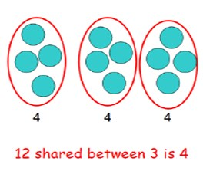

12 ÷ 3 = 4

- Grouping using a number line - Group from zero in equal jumps of the division ‘how many groups of 3 in 12?’
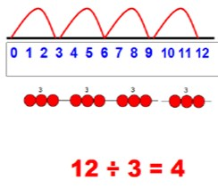

Add 3 until you reach 12.

How many lots of 3 are in 12? = 4

5. Resource sheet

