Calculation Policy for Mathematics

The following calculation policy has been devised to meet requirements of the National Curriculum 2014 for the teaching and learning of mathematics, and is also designed to give pupils a consistent and smooth progression of learning in calculations across the school. Please note that early learning in number and calculation in Foundation Stage follows the “Development Matters‟ EYFS document, and this calculation policy is designed to build on progressively from the content and methods established in the Early Years Foundation Stage.
Age stage expectations
The calculation policy is organised according to age stage expectations as set out in the National Curriculum 2014, however it is vital that pupils are taught according to the stage that they are currently working at, being moved onto the next level as soon as they are ready, or working at a lower stage until they are secure enough to move on.
Providing a context for calculation:
It is important that any type of calculation is given a real life context or problem solving approach to help build children's understanding of the purpose of calculation, and to help them recognise when to use certain operations and methods when faced with problems. This must be a priority within calculation lessons.
Choosing a calculation method:
Children need to be taught and encouraged to use the following processes in deciding what approach they will take to a calculation, to ensure they select the most appropriate method for the numbers involved:

To work out a tricky calculation:
Approximate

Calculate

Check it mate!

Can I do it in my head using a
mental strategy?

Could I use some jottings to
help me?

Should I use a written method to
work it out?

Addition
Year 1 – Adding with numbers up to 20.
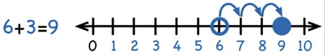
Use numbered number lines to add, by counting on in ones. Encourage children to start with the larger number and count on.

Children should:
- Have access to a wide range of counting equipment, everyday objects, number tracks and number lines and be shown numbers in different contexts.
- Read and write the addition (+) and equals (=) signs within number sentences.
- Interpret addition number sentences and solve missing box problems, using concrete objects and number line addition to solve them:
8 + 3 = 15 + 4 = 5 + 3 + 1 = + = 6

This builds on from prior learning of adding by combining two sets of objects into one group (5 cubes and 3 cubes) in Early Years.



+
=

Bead strings or bead bars can be used to illustrate addition including bridging through ten by counting on 2 then counting on 3.
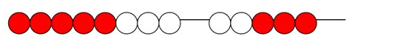
8+ 5 =

Key vocabulary: add, more, plus, and, make, altogether, total, equal to, equals, double, most, count on, number line
Key skills for addition at Y1:
- Read and write numbers to 100 in numerals, incl. 1—20 in words
- Recall bonds to 10 and 20, and addition facts within 20
- Count to and across 100
- Count in multiples of 1 2, 5 and 10
- Solve simple 1-step problems involving addition, using objects, number lines and pictorial representations.

Subtraction

Year 1 – Subtracting from numbers up to 20.
Children will consolidate their understanding of subtraction practically, showing subtraction using apparatus such as; bead strings, using cubes etc. They solve subtraction problems in familiar contexts and are introduced to more formal recording using number lines as below.

Children should:
- Read, write and interpret number sentences with – and =.
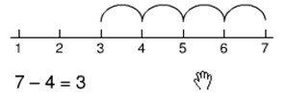
- Subtract by taking away – count back in ones on a number line to take away with numbers up to 20.
(model subtraction using
number lines, number tracks
and hundred squares.)
- Find the distance between two numbers.
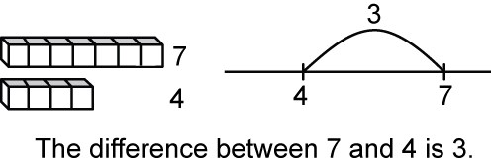
- This will be introduced practically with the language ‘find the distance between’ and ‘how many more?’ in a range of familiar contexts.
Seven is three more than four.
I am 2 years older than my sister.

- Mental subtraction – children should start recalling subtraction facts up to, and within 10 and 20, and should be able to subtract zero.

Key vocabulary: equal to, take, take away, less, minus, subtract, leaves, distance between, how many more, how many fewer / less than, most, least, count back , how many left, how much less is_?
Key skills for subtraction at Y1:
- Given a number, say one more or one less.
- Count to and over 100, forward and back, from any number.
- Represent and use subtraction facts to 20 and within 20.
- Subtract with one-digit and two-digit numbers to 20, including zero.
- Solve one-step problems that involve addition and subtraction, using concrete objects (ie bead string, objects, cubes) and pictures, and missing number problems.
- Read and write numbers from 0 to 20 in numerals and words,
Addition
Year 2 – Adding with 2 digit numbers.
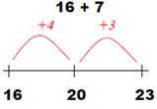
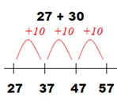
Developing mental fluency with addition and place value involving 2 digit numbers, then beginning to establish more formal methods.
Children should:
- Add a 2 digit number and tens.
- Add 2 digit numbers and units.
- Add pairs of 2 digit numbers, moving to the partitioned column method when secure at adding tens and units.
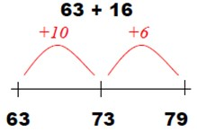
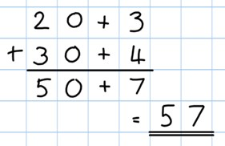
23 + 34
Step 1: Only provide examples that do NOT cross the tens boundary until the children are secure with the method itself.

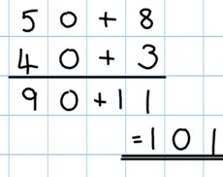
Step 2: Once children can add a multiple of ten to a 2 digit number mentally (e.g. 80+11) they are ready for adding pairs of 2 digit numbers that cross the tens boundary (e.g. 58 + 43)

Step 3: Children who are confident and accurate with this stage should move onto the expanded addition methods with 2 and 3 digit numbers (see Y3).

Key vocabulary: add, more, plus, and, make, altogether, total, equal to, equals, double, most, count on, number line, sum, tens, units, partition, addition, column, tens boundary
Key skills for addition at Y2:
- Add a 2-digit number and ones (e.g. 27 + 6)
- Add a 2-digit number and tens (e.g. 23 + 40)
- Add pairs of 2-digit numbers (e.g. 35 + 47)
- Add three single-digit numbers (e.g. 5 + 9 + 7)
- Show that adding can be done in any order (the commutative law).
- Recall bonds to 20 and bonds of tens to 100 (30 + 70 etc.)
- Count in steps of 2, 3 and 5 and count in tens from any number. Understand the place value of 2-digit numbers (tens and ones) Compare and order numbers to 100 using < > and = signs.
- Read and write numbers to at least 100 in numerals and words.
- Solve problems with addition, using concrete objects, pictorial representations, involving numbers, quantities and measures, and applying mental and written methods.

To support understanding, pupils may physically make and carry out the calculation with dienes apparatus or place value counters, then compare their practical version to the written form to help them to build an understanding of it.

Year 2 – Subtraction with 2 digit numbers
Subtraction
Subtract on a number line by counting back aiming to develop mental subtraction skills.
This strategy will be used for:
- 2 digit numbers, subtracting units (by taking away/counting back) e.g. 36-7
- 2 digit numbers, subtracting tens (by taking away/counting back) e.g. 48 – 30
- Subtracting pairs of 2 digit numbers (see below):

Using a number line:
47-23 = 24 Partition the second number and Move towards more
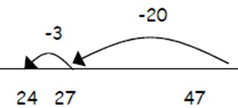
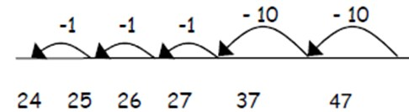
subtract it in tens and units, as below: efficient jumps back:

jhkhCom
Combine methods on a number line with a hundred square to reinforce value and order.
Subtract
Subtract 10’s first
Then subtract units

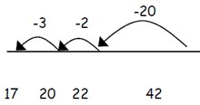
Teaching children to bridge through ten can
help them to become more efficient e.g.

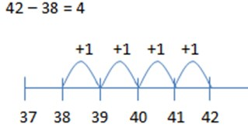
Mental strategy – subtract numbers close together by counting on:
Many mental strategies are taught. Children are taught to recognise that when numbers are close together, it is more efficient to count on the difference. They need to be clear about the relationship between additional and subtraction.
Start on the smaller number then count on.

Key vocabulary: equal to, take, take away, less, minus, subtract, leaves, distance between, how many more, how many fewer/less than, most, least, count back, how many left, how much less is _ ?difference, count on, strategy, partition, tens, units
Key skills for subtraction at Y2:
- Recognise the place value of each digit in a two-digit number.
- Recall and use subtraction facts to 20 fluently and derive and use related facts up to 100.
- Subtract using concrete objects, pictorial representations, 100 squares and mentally, including: a two-digit number and ones, a two-digit number and tens, and two two-digit numbers.
- Show that subtraction of one number from another cannot be done in any order.
- Recognise and use inverse relationship between addition and subtraction, using this to check calculations and missing number problems.
- Solve simple addition and subtraction problems including measures, using concrete objects, pictorial representation, and also applying their increasing knowledge of meantal and written methods.
- Read and write numbers to at least 100 in numerals and in words.
Addition

Year 3 – Add numbers with up to 3 digits.
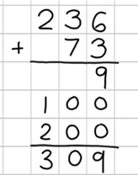
Introduce the expanded column addition method:
a
Add the units first, in preparation for the compact method.

In order to carry out this method of addition:
- Children need to recognise the value of the hundreds, tens and units without recording the partitioning.
- Pupils need to be able to add in columns.
Move to the compact column addition method with carrying:
Children who are very secure and confident with the 3 digit expanded column addition method should move onto the compact column addition method. They will be introduced to carrying for the first time. Compare the expanded method to the compact column method to develop an understanding of the process and the reduced number of steps involved.
Carry numbers underneath the bottom line.
Remind the children the actual values of the numbers in the compact column method are hundreds, tens and units, not just units.
2 3 6
+ 7 3
3 0 9
1
Add units, then tens and hundreds

Key vocabulary: add, more, plus, and, make, altogether, total, equal to, equals, double, most, count on, number line, sum, tens, units, partition, plus, addition, column, tens boundary, hundreds boundary, increase, vertical, ‘carry‘, expanded, compact
Key skills for addition at Y3:
- Read and write numbers to 1000 in numerals and words.
- Add 2-digit numbers mentally, incl. those exceeding 100.
- Add a three-digit number and ones mentally (175 + 8)
- Add a three-digit number and tens mentally (249 + 50)
- Add a three-digit number and hundreds mentally (381 + 400) • Estimate answers to calculations, using inverse to check answers. • Solve problems, including missing number problems, using • number facts, place value, and more complex addition.
- Recognise place value of each digit in 3-digit numbers (hundreds, tens, and ones.)
- Continue to practise a wide range of mental addition strategies, ie. Number bonds, adding the nearest multiple of 10, 100, 100 and adjusting, using near doubles, partitioning and recombining.

Subtraction
Year 3 – Subtracting 2 and 3 digit numbers.
Introduce partitioned column subtraction method.
When learning to ‘exchange’, explore partitioning in different ways so that understand that when you exchange, the VALUE is the same i.e. 72 = 70 + 2 = 60 + 12 = 50 + 22 etc. Emphasise that the value hasn’t changed, we have just partitioned in a different way.
When
Step 1: Introduce this 89 – 35 = 54
method with examples 80 + 9
where no exchanging - 30 + 5
is required. 50 + 4

Step 2: Introduce the exchanging through
practical subtraction. Make the larger number
with dienes, then subtract 47 from it.

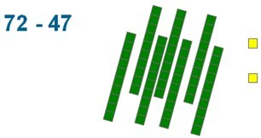
Before subtracting ‘7’ from the 72 blocks, they will need to exchange a row of 10 for ten units. Then subtract 7, and subtract 4 tens.

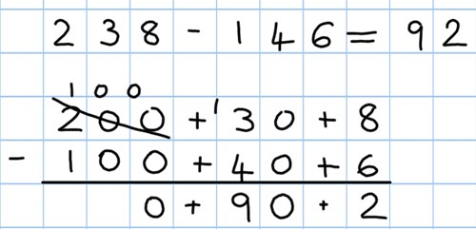
Step 3: Once pupils are secure with the understanding
of ‘exchanging’, they can use the partitioned column
method to subtract and 2 and 3 digit numbers.

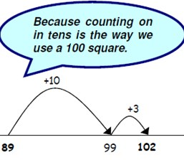
Counting on as a mental strategy for subtraction:
Continue to reinforce counting on as a strategy for close-together numbers (e.g. 121—118), and also for numbers that are ‟nearly‟ multiples of 10, 100, 1000 or £s, which make it easier to count on (e.g. 102-89, 131—79, or calculating change from £1 etc) Start at the smaller number and count on in tens first, then count on in units to find the rest of the difference:

Key vocabulary: equal to, take, take away, less, minus, subtract, leaves, distance between, how many more, how many fewer / less than, most, least, count back , how many left, how much less is_? difference, count on, strategy, partition, tens, units exchange, decrease, hundreds, value, digit
Key skills for subtraction at Y3:
- Subtract mentally a: 3 digit number and ones, 3 digit number and tens, 3 digit number and hundreds.
- Estimate answers and use inverse operations to check.
- Solve problems, including missing number problems.
- Find 10 or 100 more or less than a given number.
- Recognise the place value of each digit in a 3 digit number.
- Counting up differences as a mental strategy when numbers are close together or near multiples of 10.
- Read and write numbers up to 1000 in numerals and words.
- Practise mental subtraction strategies, such as subtracting near multiples of 10 and adjusting (e.g. – 19 or 21)

Multiplication

Year 1 – Multiply with concrete objects, arrays and pictorial representations.
How many legs will 3 teddies have? There are 3 sweets in one bag. How many sweets are in
5 bags altogether?
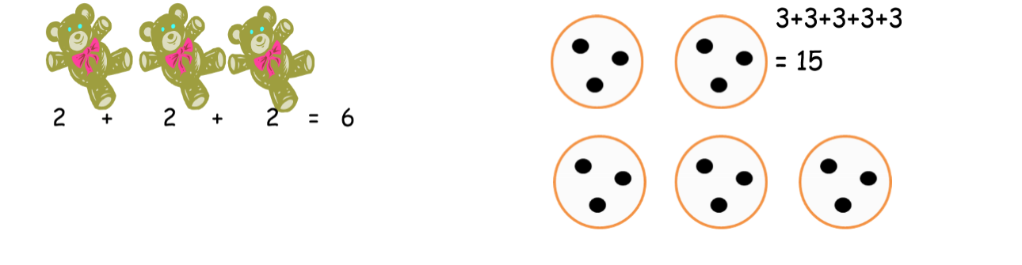

Give children experience of counting equal group of objects in 2s, 5s and 10s.
Present practical problem solving activities involving counting equal sets or groups as above.

Key vocabulary: groups of, lots of, times, array, altogether, multiply, count

Key skills for multiplication at Y1:

Count in multiples of 2, 5 and 10.
Solve one-step problems involving multiplication, by calculating the answer using concrete objects, pictorial representations and arrays with the support of the teacher.
Make connections between arrays, number patterns, and counting in twos, fives and tens.
Begin to understand doubling using concrete objects and pictorial representations.

Division
Year 1 – Group and share small quantities
Using objects, diagrams and pictorial representations to solve problems involving both grouping and sharing.

How many groups of 4 can be made with 12 stars? = 3


Example division problem in a familiar context:
There are 6 children on this table and there are 18 pieces of fruit to shre between us. If we share them equally, how many will we each get?
Can they work it out and give a division statement …?
“18 shared between 6 people gives you 3 each.’
Grouping:
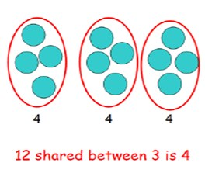
Sharing:

Children should:
Use lots of practical apparatus, arrays and picture representations.
Be taught to understand the difference between grouping objects (How many groups of 2 can you make?) and sharing (Share these sweets between 2 people)
Be able to count in multiples of 2s, 5s and 10s.
Find half of a group of objects by sharing into 2 equal groups.

Key Vocabulary: share, share equally, one each, two each…, group, groups of, lots of, array

Key number skills needed for division at Y1:
- Solve one-step problems involving multiplication and division, by calculating the answer using concrete objects, pictorial representations arrays with the support of the teacher
- Through grouping and sharing small quantities, pupils begin to understand, division, and finding simple fractions of objects, numbers and quantities.
- They make connections between arrays, number patterns, and counting in twos, fives and tens.

Multiplication
Year 2 – Multiply using arrays and repeated addition (using at least 2s, 5s and 10s)
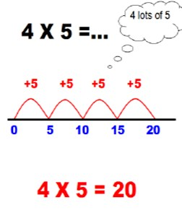
Use repeated addition on a number line:
Starting from zero, make equal jumps on a
number line to work out multiplication facts
and write multiplication statements using x
and = signs.
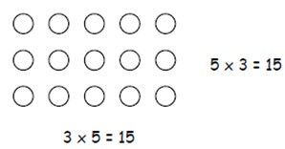
Use arrays:
5 x 3 – 3 + 3 + 3 + 3 + 3 = 15
3 x 5 = 5 + 5 + 5 = 15

Use arrays to help teach children to understand the commutative law of multiplication, and give examples such as 3 x _ = 6
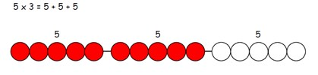
Use practical apparatus:

Use mental recall: Children should begin to recall multiplication facts for 2, 5 and 10 times tables through practise in counting and understanding of the operation.
Key vocabulary: groups of, lots of, times, array, altogether, multiply, count, multiplied by, repeated addition, column, row, commutative, sets of, equal groups, times as big as, once, twice, three times...
Key skills for multiplication at Y2:
- Count in steps of 2, 3 and 5 from zero, and in 10s from any number.
- Recall and use multiplication facts from the 2, 5 and 10 multiplication tables, including recognising odds and evens.
- Write and calculate number statements using the x and = signs.
- Show that multiplication can be done in any order (commutative).
- Solve a range of problems involving multiplication, using concrete objects, arrays, repeated addition, mental methods, and multiplication facts.
- Pupils use a variety of language to discuss and describe multiplication.

Division
Year 2 – Group and share, using the ÷ and = sign
Use objects, arrays, diagrams and pictorial representations and grouping on a number line.
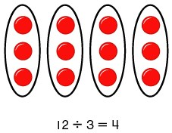
Arrays: This represents 12 ÷ 3 posed as how many groups of 3 are in 12?
Pupils should also show that the same array can represent 12 ÷ 4 = 3.

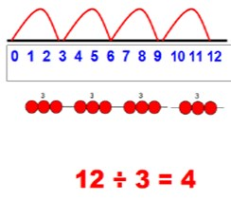
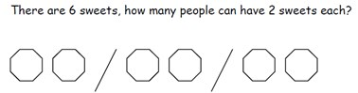
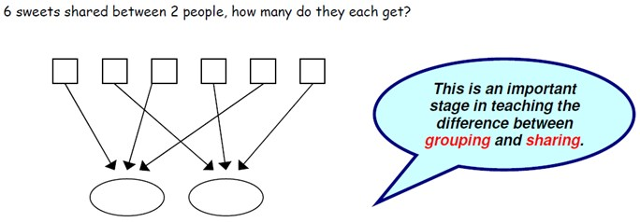
Know and understand sharing and grouping:
Children should be taught to recognise whether problems require sharing or grouping.
Grouping
Sharing

Grouping using a number line: Group from zero in equal jumps of the division ‘how many groups of _ in _?’ Pupils could add using a bead string or practical apparatus to work out problems like ‘A CD costs £3. How many CDs can I buy with £12?’ This is an important method to develop understanding of division as grouping.
- Key Vocabulary: share, share equally, one each, two each…, group, equal groups of, lots of, array, divide, divided by, divided into, division, grouping, number line, left, left over
- Key number skills needed for division at Y2:
- Count in steps of 2, 3, and 5 from 0
- Recall and use multiplication and division facts for the 2, 5 and 10 multiplication tables, including recognising odd and even numbers.
- Calculate mathematical statements for multiplication and division within the multiplication tables and write them using the x, ÷ and = signs.
- Show that multiplication of two numbers can be done in any order (commutative) and division of one number by another cannot.
- Solve problems involving multiplication and division, using materials, arrays, repeated addition, mental methods, and multiplication and division facts, including problems in contexts.

Multiplication
Year 3 – Multiply 2-digits by a single digit number
Introduce the grid method for multiplying 2-digit by single digits:
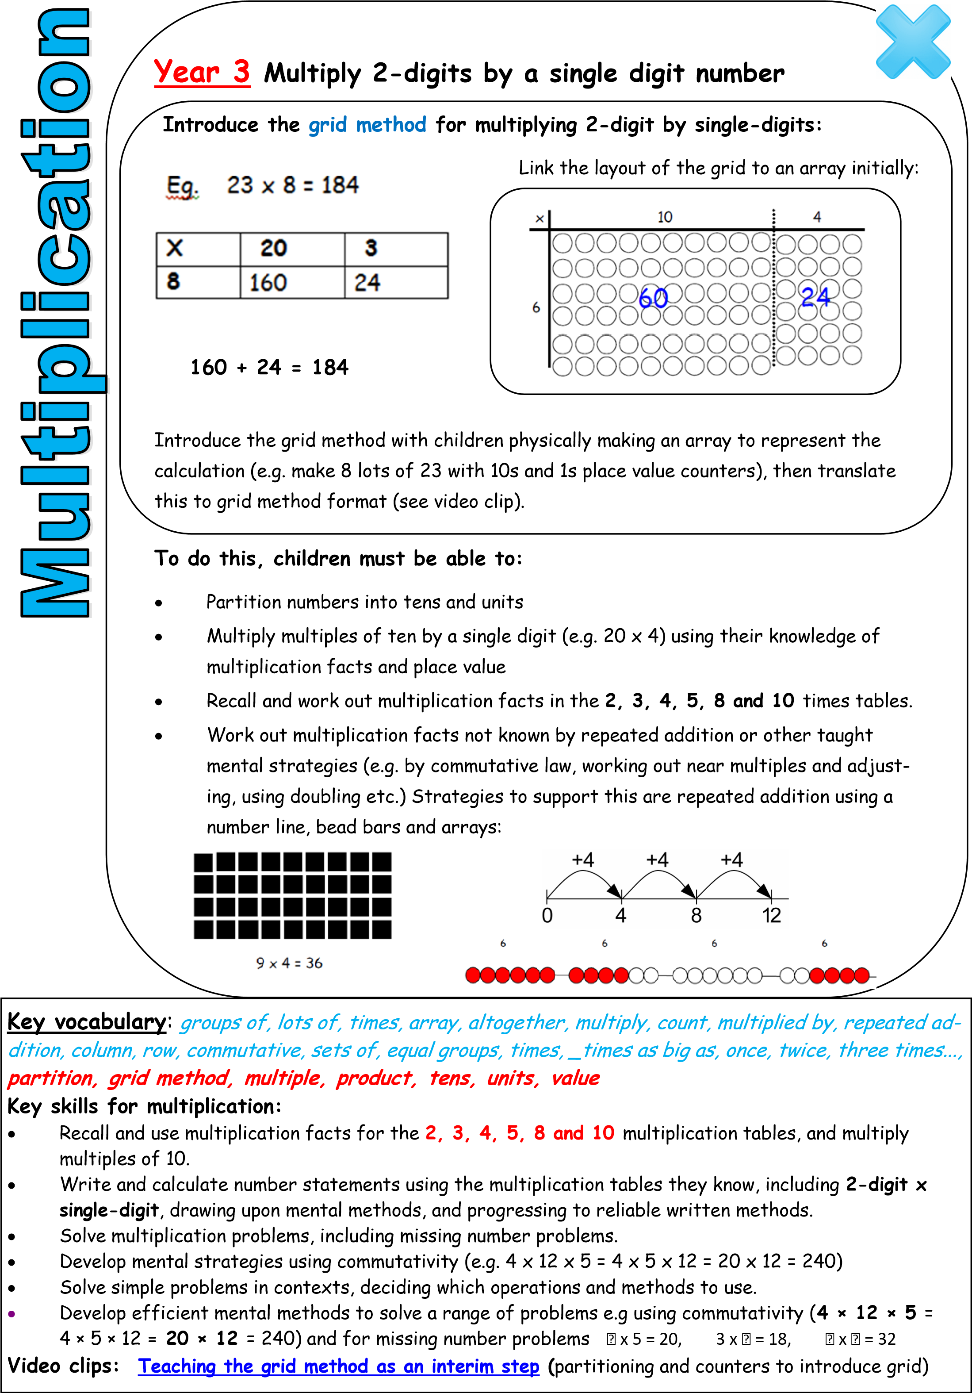
Introduce the grid method with children physically making an array to represent the calculation (e.g. make 8 lots of 23 with 10s and 1s place value counters), then translate this to grid method format.

To do this, children must be able to:
-Partition numbers into tens and units.
-Multiply multiples of ten by a single digit (eg. 20 x 4) using their knowledge of multiplication facts and place value.
-Recall and work our multiplication facts in the 2, 3, 4, 5, 8 and 10 times tables.
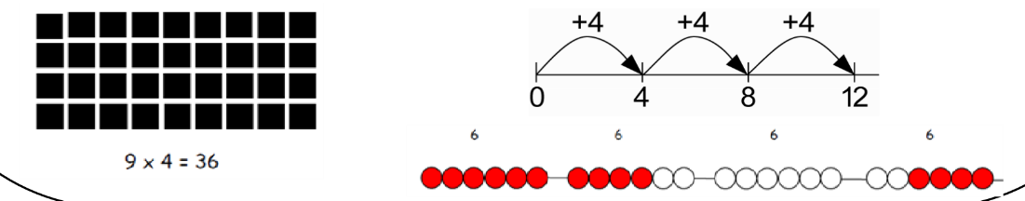
-Work out multiplication facts not known by repeated addition or other taught mental strategies (e.g. by commutative law, working out near multiples and adjusting, using doubling etc.) Strategies to support this are repeated addition using a number line, bead bars and arrays:
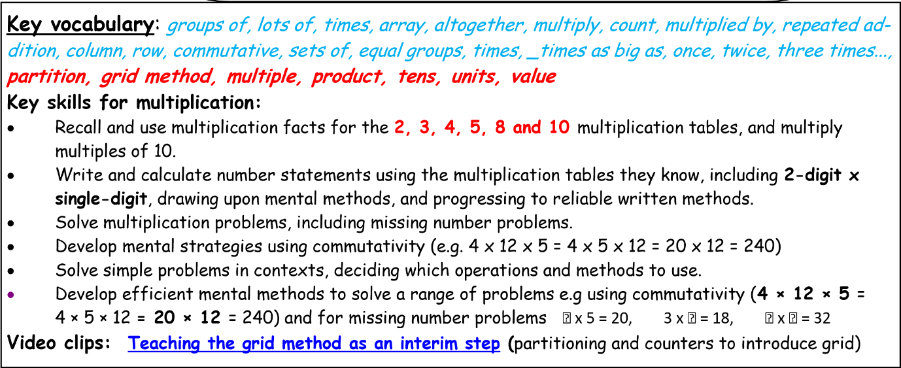
Division
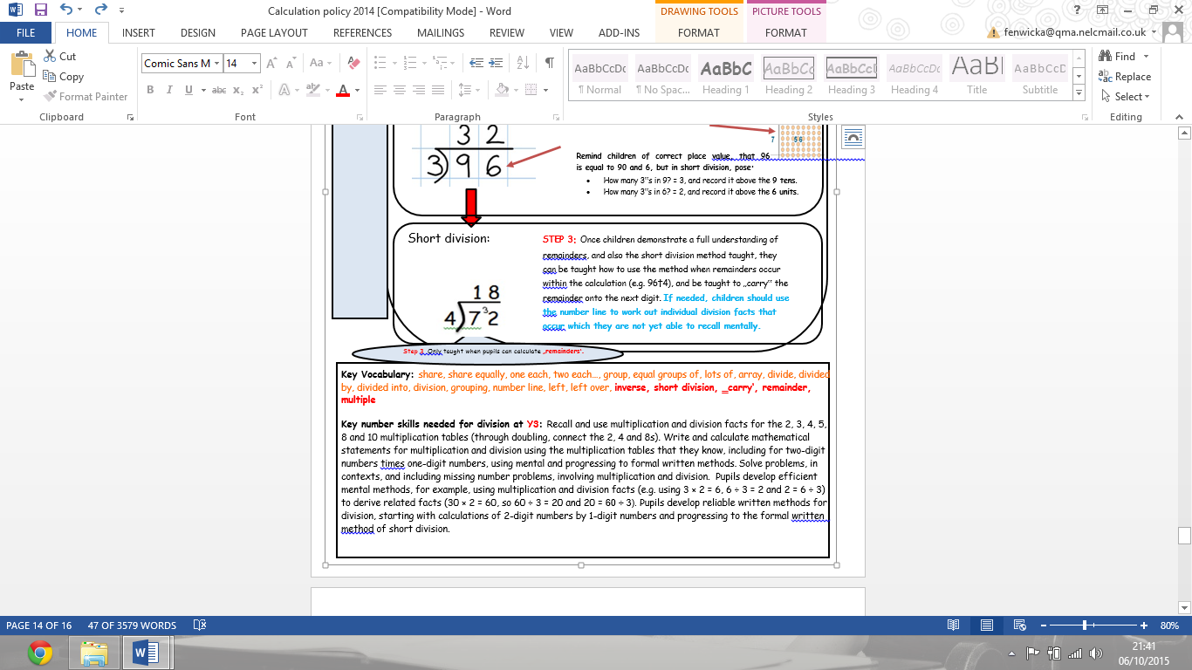
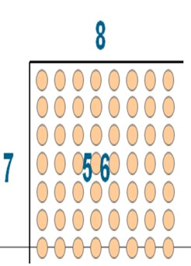
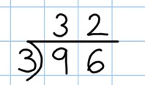
Year 3 – Divide 2 digit numbers by a single digit (where there is no remainder in the final answer)
STEP 2: Once children are secure with division as grouping and demonstrate this using number lines, arrays etc, short division for larger 2 digit.
Short division: numbers should be introduced, initially with carefully selected examples requiring no calculating of remainders at all. Start by introducing the layout of short division by comparing it to an array.
Remind children of correct place value, that 96 is equal to 90 and 6, but in short division, pose:
How many 3‟s in 9? 3, and record it above the 9 tens.
How many 3‟s in 6? 2, and record it above the 6 units.

+3 +3 +3 +3 r1
Grouping on a number line: STEP 1: Children continue to work out unknown division facts by grouping on a number line from zero. They are also now taught the concept of remainders,
as in the example. This should be introduced practically and with arrays, as
well as being translated to a number line. Children should work towards
calculating some basic division facts with remainders mentally for the
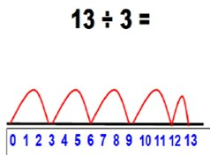2s, 3s, 4s, 5s, 8s and 10s, ready for ‘carrying’ remainders across within the
short division method.

