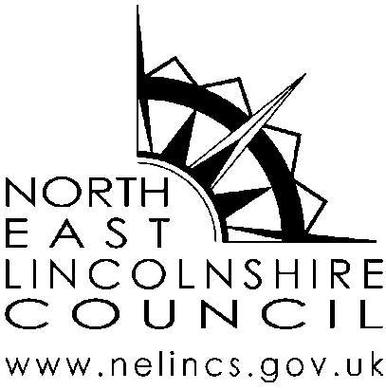
Enquiries: | Diane Grimshaw
Direct Dial: | 01472 323074
Email: | diane.grimshaw@nelincs.gov.uk
Date: | 2 November 2021

TO: THE GOVERNORS ON THE RESOURCES COMMITTEE OF QUEEN MARY AVENUE INFANT AND NURSERY SCHOOL

Mr M Brett, Miss E Harrison, Mr J Harris, Mrs V Matthews, Mrs E Powell,
Mr M Ward, Mrs L Blow (by invitation)

Cc Mrs M Castle

Dear Governor

There will be a meeting of the Resources Committee on Monday 8 November 2021 at 9.30am and the agenda is set out below. The meeting is in the school but if any Governor wishes to attend virtually, please let me know and arrangements will be made. I hope you are available to attend and would appreciate any apologies for absence.

Yours sincerely

Diane R Grimshaw

Clerk to the Governing Body
--------------------------------------------------------------------------------------------------------------

AGENDA
Governors are reminded that if they have a financial interest in any item under consideration it is a requirement for them to withdraw from the meeting for that item

1. Apologies
2. Pecuniary interests
3. Minutes of previous meeting (25.05.21) and matters arising
(The Minutes will be available on the Governors’ secure section of the school website)
4. Budget update
5. Health and Safety
6. Performance management
7. Staffing updates
8. Date of next meeting
9. Any other business

